Assignment-1

Name: Sujeeth

Reg no: 720719104601

CIRCUIT DIAGRAM:

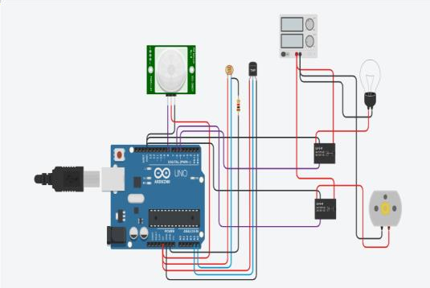

PROGRAM CODE:

Float x,y,z,temp; void setup()

{ pinMode(8, INPUT); pinMode(5, OUTPUT); pinMode(6, OUTPUT); pinMode(A5, INPUT); pinMode(A4, INPUT); Serial.begin(9600); } void loop()

{ x= digitalRead(8); y= analogRead(A5); z=analogRead(A4);

Serial.println(x); Serial.println(y);

Serial.println(z); temp=(double)z/1024; temp=temp\*5; temp=temp -0.5; temp=temp \*100; if((x>0))

{

if((y<550)&&(temp>30))

{ digitalWrite(5, HIGH); digitalWrite(6, HIGH);} else

if((y<550)&&(temp<30))

{ digitalWrite(5, HIGH); digitalWrite(6, LOW); } else if((y>550)&&(temp>30))

{ digitalWrite(5, LOW); digitalWrite(6, HIGH);}else if((y>550)&&(temp<30))

{ digitalWrite(5,LOW); digitalWrite(6, LOW);

} } else

{ digitalWrite(5,LOW); digitalWrite(6,LOW);

}

}